# Kimiko’s Canvas Application

## Overview

This application will function as a photo gallery for an up and coming photographer. The user will be able to log in and be show a list of photos. The user will be able to click on a photo and see where the photo was taken.

**This application will be written in the Kotlin language and use the MVVM/Repository Design pattern.**

## Structure/Libraries

The Application will consist of one Activity and 3 Fragments.

* Firebase (Auth, API, Data Persistence)
* Glide
* Google Maps SDK
* Kotlin Coroutines
* MVVM Architecture
* Koin
* MotionLayout

## Glide

* Glide will be our image loading library that will work in congruence with Firebase Storage to retrieve images based on their URL

## 

## 

## Google Maps SDK

* Google Maps will be utilized to show our user where the image was taken.
* The user will be able to grant location permissions to see approximately how far they are from where the photo was taken.

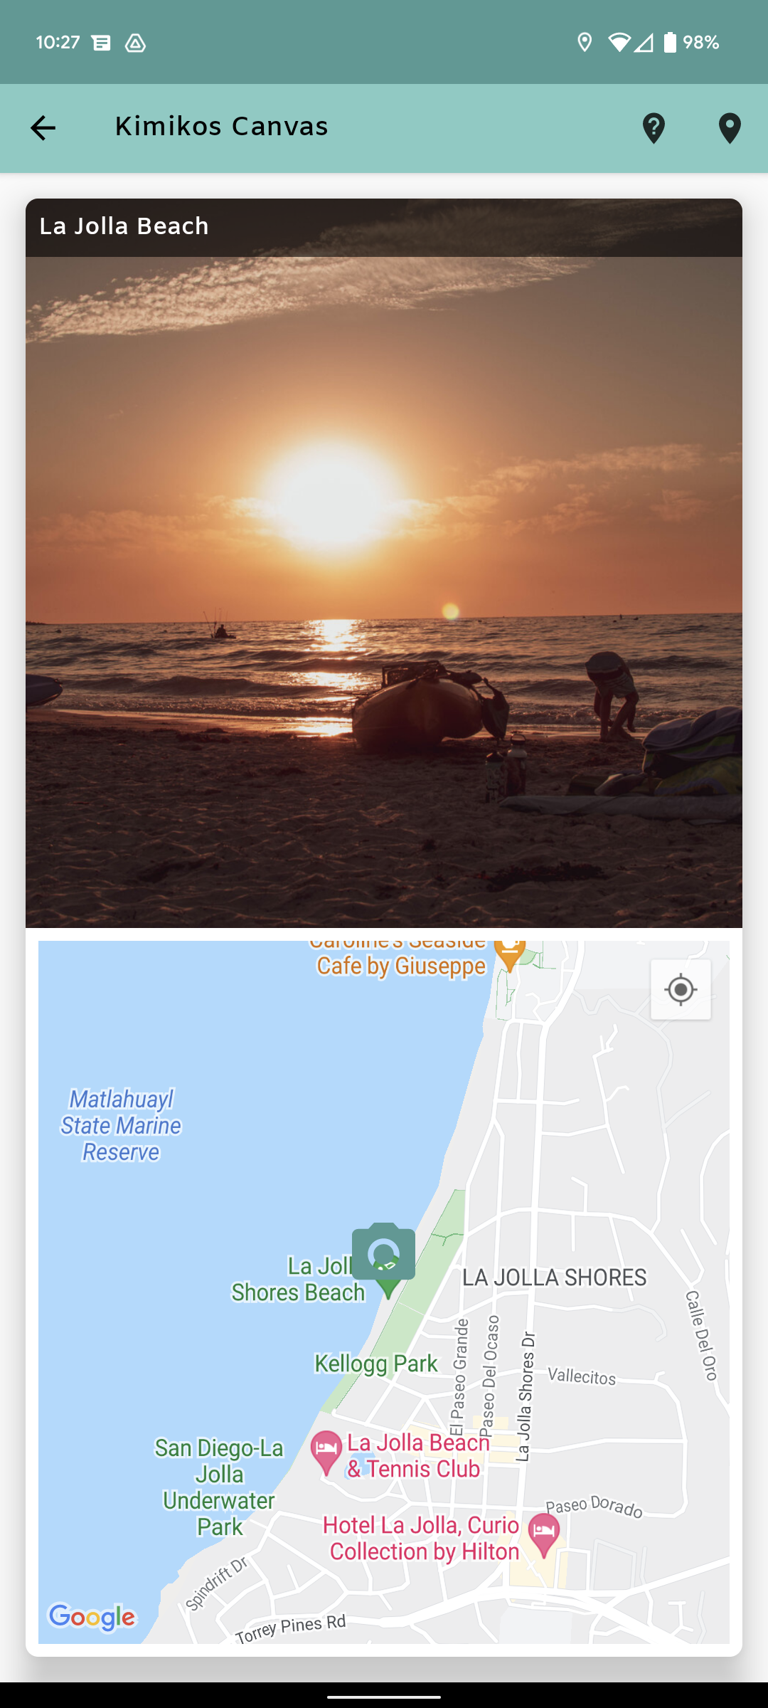

## Kotlin Coroutines

* Coroutines will handle asynchronous code, allowing our UI thread to not get bogged down with long running tasks.
* This will be useful for if we are retrieving a long list of items from our realtime database.

## MVVM/Repository Pattern

* We will use MVVM Repository Pattern to separate our business logic from our views

## Koin

* We use Koin for dependency injection which will allow us to test our classes separately.

## MotionLayout

We will use motion layout when clicking on the image in our list. It will enlarge the image to get a better view of our photos.